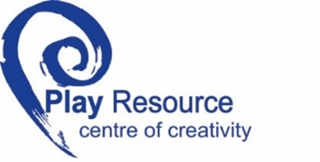
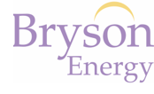
INDIVIDUAL COMMUNITY ARTIST APPLICATION

Annual membership fee is £75 +VAT – You will be the only named person on this account

Surname:
First Name:
Address:
Town/City:
Postcode:
Tel No: |  | Email:

Most Recent experience of working with Community Arts Projects
Name, Address, Telephone number of Group worked with | Type of Project | Duration |  |  |  |  |  | Description
 |  |  | From |  |  | To

Details of Qualifications relevant to Arts
Name: | Course: | Grades: | Date From: | Date To:

Further details

Please tell us about your work as a community artist:

References
Please provide two written references who know of your work as a Community artist. These references must be attached to this application on headed paper.

1.Name:
Address:
Occupation:
2.Name:
Address:
Occupation:

Signature: _____________________________________ Date_________________________________________

Tel No: ______________________________________ Email:_______________________________________

Bryson Energy Play Resource Terms & Conditions of Membership

Bryson Energy Play Resource is a registered charity operating as a social enterprise. Membership of Bryson Play Resource is open to any group or individual who adheres to Bryson Energy Play Resource’s Terms and Conditions of Membership.
Membership of Bryson Play Resource entitles groups and individuals to use the services provided by the charity.
• Anyone or any group using these services must be a current member.
• Membership cards are non-transferable. Only the persons named on the membership card can use the centre.
- Cardholders cannot bring non-cardholders into Bryson Play Resource.
- Cardholders cannot collect on behalf of non-member groups. Failure to comply with this will result in membership being withdrawn.
- We do not offer membership to Artist Collectives – each Artist must join individually. Please contact Claire on 02890 357548 for further information
VISITING OUR SCRAPSTORE
• Upon arrival at Bryson Energy Play Resource, membership cards must be scanned at reception.
• For Health and Safety reasons, all children must be accompanied by an adult.
• Some of our materials may be a hazard to children and will be taken at the discretion of the member.

FAIR USAGE POLICY
• Any materials supplied by Bryson Energy Play Resource must be used solely for the activities of the member group named on the membership. The materials must not be resold, exchanged, or used for any other purpose.
• Materials must not be used for commercial or private use. Any member found selling our free materials will have their membership withdrawn.
• Bryson Energy Play Resource reserves the right to place limits on quantities of materials collected.
• Bryson Energy Play Resource requests that members only take reasonable amounts of materials, Members are encouraged to not take more than is needed for their service.
• Bryson Energy Play Resource reserves the right to change the terms of the Fair Usage Policy as seen fit.

MEMBERSHIP ADMINISTRATION
• Renewal of Membership will be backdated to the date of expiry, and will last 12 months from that date, regardless of the date on which the renewal fee was received.
- Once your membership has lapsed past 6 months your group will have to apply for a new membership.

Bryson Energy Play Resource has the right to refuse or rescind membership to any group whom they feel contravenes the Bryson Energy Play Resource Terms and Conditions of Membership. A member has the right to appeal to the Management Board against such a decision. Bryson Energy Play Resource reserves the right to alter or otherwise add to these conditions by giving written notice.

